Functionalized Iron Oxide Nanoparticles as Microplastic Adsorbents – A Brief Review
Revathy Sundara Moorthy¹, Rohini Rondla¹, M. Kavitha¹, T. Sowmyya², B.Vijaya Kumar¹ and P. Muralidhar Reddy ¹*
- Department of Chemistry, University College of Science, Osmania University, Hyderabad, Telangana, India
- Forensic Science Unit, Department of Chemistry, University College of Science, Osmania University, Hyderabad, Telangana, India
Correspondence: P. Muralidhar Reddy: pmdreddy@gmail.com, pmdreddy@osmania.ac.in; Tel.: 9848792423
Abstract. Plastic usage has become an indispensable one in day-to-day life and in every place. As being part of our life, their consequences too became part of the environment. Presently, micro and nano-plastic contamination in every nook and corner of the environment is more threatening as they are having drastic effects on living organisms and are the major reason for the carcinogenic effect on humans. On considering its ill effects, there is a pressing need to develop the methodology for detection and effective removal of these micro and nano-plastic. Though there are conventional methods coming up, yet they are either time taking, laborious, costly or all together. Hence, its necessary to improvise the conventional methods or develop new technologies for effective removal. Based on the literature survey, in this review we are summarizing the recent advances in using Iron oxide nanoparticles (IONPs) and functionalized IONPs coated with carbon nanotubes, Phosphonic acid, PETase enzyme and Silica- IL (Ionic liquid) for removal of micro and nano-plastics, due to their special magnetic property aiding in easy and specific isolation of micro and nano-plastics.
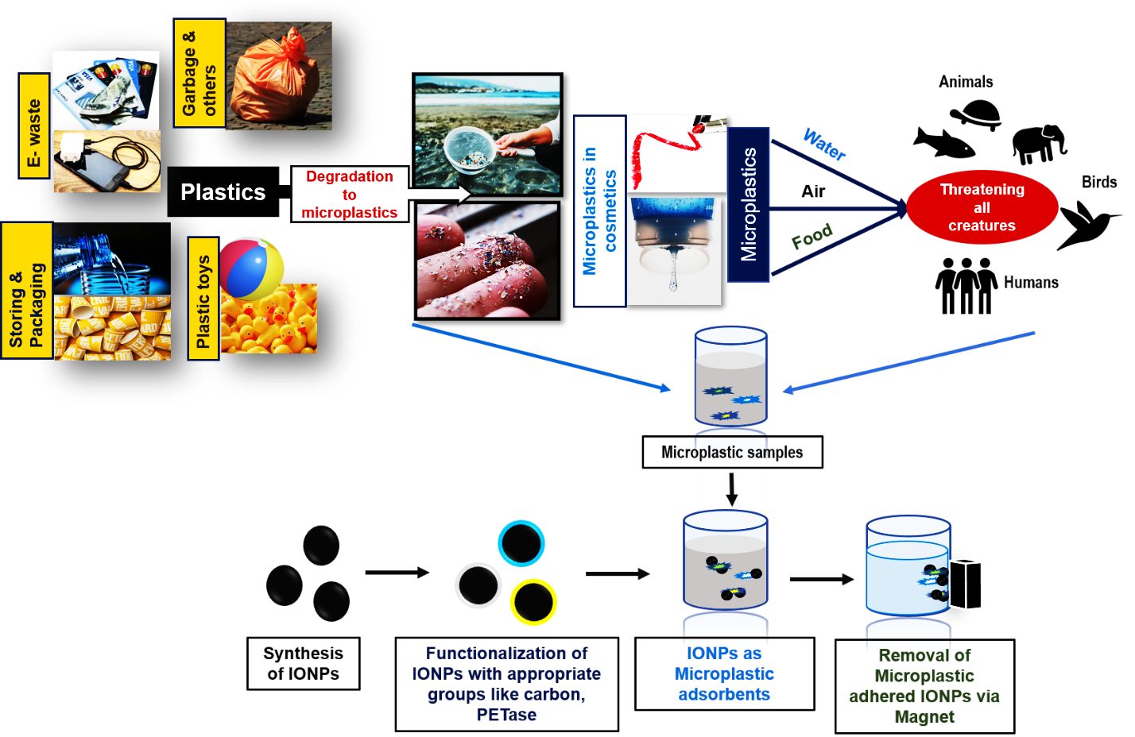

References:

- Schwaminger, S. P.; Fraga-García, P.; Eigenfeld, M.; Becker, T. M.; Berensmeier, S., Front. Bioeng. Biotechnol. 2019, 7, 233.10.3389/fbioe.2019.00233,Schwaminger, S. P.; Bauer, D.; Fraga-García, P.; Wagner, F. E.; Berensmeier, S., Cryst. Eng. Comm. 2017, 19.(2), 246-255.10.1039/C6CE02421A
- Campanale, C.; Massarelli, C.; Savino, I.; Locaputo, V.; Uricchio, V. F., Int. J. Environ. Res. Public Health. 2020, 17.(4), 1212.10.3390/ijerph17041212
- Madhusudhana Reddy, P.; Chang, C.-J.; Chen, J.-K.; Wu, M.-T.; Wang, C.-F., Applied Surface Science 2016, 368, 27-35.https://doi.org/10.1016/j.apsusc.2016.01.250
- Leslie, H. A.; van Velzen, M. J. M.; Brandsma, S. H.; Vethaak, A. D.; Garcia-Vallejo, J. J.; Lamoree, M. H., Environ. Int. 2022, 107199.https://doi.org/10.1016/j.envint.2022.107199
- Misra, A.; Zambrzycki, C.; Kloker, G.; Kotyrba, A.; Anjass, M. H.; Franco Castillo, I.; Mitchell, S. G.; Güttel, R.; Streb, C., Angew. Chem. Int. Ed. 2020, 59.(4), 1601-1605.https://doi.org/10.1002/anie.201912111

