Structural, morphological, and infrared investigations after the formation of Cinnamaldehyde-N-methyl aniline, a Schiff base ligand based on aniline.
Ankit Singh Chouhan*¹, Suprajnya Thakur¹, Manvendra Kumar¹, Mukul Gupta², Fouran Singh³, Sunil Ojha³ and Anit Dawar³

¹Department of Physics, SVIS, Shri Vaishnav Vidyapeeth Vishwavidhlaya, Indore.
²UGC-DAE Consortium for Scientific Research, Indore.
³Inter University Accelerator Centre, New Delhi.
*Corresponding Author: ankit12ipss@gmail.com

Abstract. In the past, scientists were able to identify the characteristics of Schiff bases and their metal complexes. Currently, a great deal of research is being done to learn more about the special characteristics of the aniline-based Schiff bases. This article describes how to make the Schiff base ligand that is based on aniline: Cinnamaldehyde - N-methyl aniline. After the synthesis of the ligand Cinnamaldehyde-N-methyl aniline, Structural, morphological and infrared analyses were conducted through the use of X-ray diffraction (XRD), Fourier-transform infrared spectroscopy (FTIR) and Field emission scanning Electron microscope (FE-SEM.
Keywords: Schiff base, Ligand, Aniline, XRD, FTIR, FE-SEM.
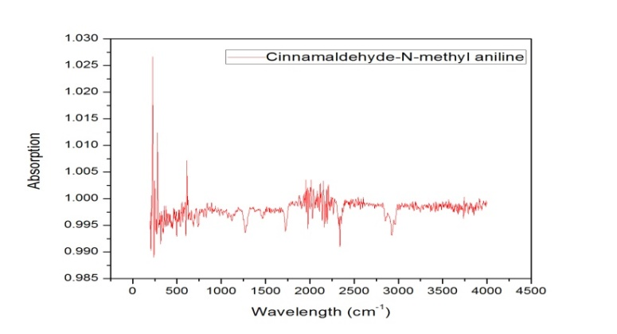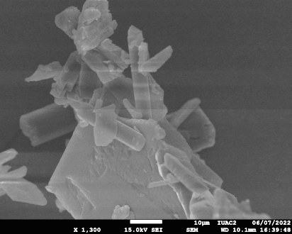
References:
[1]. Turki AA. Synthesis and Characterization of Some New Schiff Base Derivatives from 4- Nitro- o –Phenylene diamine. J Kerbala Univeristy. 2012;10(3):259–266.
[2]. Kumar N, Sharma P. Synthesis of New Schiff- Base Complexes and Their Applications. Int J Appl Res study. 2013;2(2):1–6.
[3]. Cinarli A, Gurbuz D, Tavman A, Seher Birtesoz A. Synthesis, spectral characterization and antimicrobial activity of some schiff bases 4-chloro-2-aminophenol. Bull Chem Soc Ethiop. 2011;25(3):407–417.
[4]. Chowdhury DA, Uddin MN, Hoque F. Dioxouranium ( VI ) Complexes of Some Bivalent Tridentate Schiff-base Ligands Containing ONS Donor Set. Chain Mai J Sci. 2010;37(3):443–450.
[5]. Ashraf MA, Mahmood K, Wajid A, Maah MJ, Yusoff I. Synthesis , Characterization and Biological Activity of Schiff Bases. Int Conf Chem adn Chem Process. 2011;10:1–7.

