Frustrated effect in Co²⁺ spin-3/2 zigzag chains
Compound: Co₃P₂O₈

Shalini Mishra², Ritu Kumawat¹, Sunidhi Chouhan¹, Isha¹, Koushik Chakraborty¹, Netram Kaurav², A. K. Yogi¹

¹UGC-DAE Consortium for Scientific Research, University Campus, Khandwa Road, Indore-452001, India
²Govt. Holkar Science College, A.B. Road, near Bhawarkua Square, Indore, Madhya Pradesh 452001 India
Email address –imshalini09@gmail.com

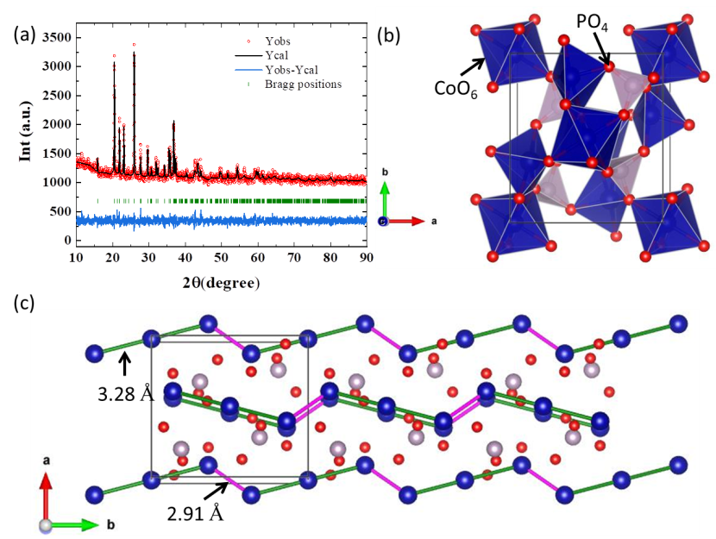
Fig. 1: XRD & crystal structure of Co₃P₂O_{8.}
The search for exotic ground states in low-dimensional quantum magnets with geometric frustration has been a very active research field of both theoretical and experimental studies. We report a comprehensive investigation of the synthesis of new low-dimensional quantum magnets and studied their structural properties in detail. We have used solid-state reaction technique to prepare Co₃P₂O₈ polycrystalline sample. To check the synthesis progress and structural properties of Co₃P₂O₈, we have used the lab source 1.54 Å (Cu-K_{α}) x-ray diffraction technique which confirms the formation of single-phase monoclinic compound with lattice parameters a = 7.556, b = 8.371, c = 5.064, α = 90, β = 94.05˚, γ = 90˚ and the space group P 2₁/n at 700 ˚C. We have observed the color of the material changed from black to purple at the above-mentioned temperature. For detailed crystallographic information of the synthesized compound we have used Rietveld refinement method over collected powder x-ray diffraction data and the goodness of fit values obtained are found to be χ² = 1.38 and R-factor = 2.71. The representative refined pattern is shown in Fig. 1 (a) indicating the synthesized compound is in single phase and has monoclinic P 2₁/n symmetry. The crystal structure of Co3P2O8 compound in crystallographic ab-plane is shown in Fig. 1 (b). From our bond valance sum (BVS) analysis we found that Co is in +2 oxidation state. Interestingly, Co²⁺ ions are forming 1D zigzag chains along the crystallographic direction b-axis are shown in Fig. 1 (c). The zigzag chains of Co²⁺ ions can introduce frustration in the magnetic-lattice. The shorter bond-distances of Co-Co atoms indicate Co₃P₂O₈ host dimers (2.91 Å) in the lattice may show interesting magnetic properties.

