Enhancing Power Quality in DFIG-Based Grid-Connected Wind System: A Comparative Analysis of UPFC and D-STATCOM

Pratiksha maroti Padole
PG Research Scholar,Department of Electrical Engineering
G H Raisoni college of Engineering
Nagpur, India
pratiksha.padole.trs@ghrce.raisoni.net

Dr. Prema Daigavane
Professor, Department of Electrical Engineering
G H Raisoni college of Engineering
Nagpur, India prema.daigavane@raisoni.net

Rutuja Hiware
Assistant Professor,Department of Electrical Engineering
G H Raisoni College of Engneering
Nagpur,India rutuja.hiware@raisoni.net

Abstract— In grid-connected wind systems, maintaining high power quality is essential for stable operation, particularly when using Doubly Fed Induction Generator (DFIG)-based wind turbines. This paper presents a comparative analysis of two advanced power electronic devices—Unified Power Flow Controller (UPFC) and Distribution Static Synchronous Compensator (D-STATCOM)—for enhancing power quality in such systems. The study focuses on their effectiveness in mitigating power quality issues like voltage sags, harmonics, and reactive power imbalances. Using MATLAB/Simulink, simulations of DFIG-based systems are conducted to evaluate the impact of each device on grid stability under various fault conditions and dynamic load scenarios. Results show that while both UPFC and D-STATCOM improve power quality, UPFC provides superior control over active and reactive power flow, leading to better grid synchronization and voltage stability. On the other hand, D-STATCOM proves more efficient in mitigating voltage fluctuations and harmonics. The paper also highlights the operational and economic trade-offs between these devices, offering insights for optimal selection based on system requirements and grid conditions. This work contributes to the efficient integration of renewable energy sources, ensuring reliable and high-quality power delivery to the grid.
Keywords—Power Quality, Grid-Connected Wind Systems, Unified Power Flow Controller (UPFC), Distribution Static Synchronous Compensator (D-STATCOM), Doubly-fed induction generator (DFIG) , Renewable Energy Integration, Voltage Stability, Harmonic Mitigation, Reactive Power Support.

Introduction
The rapid expansion of renewable energy systems has made wind power a key player in the global energy mix. Among the various technologies, grid-connected systems based on Doubly-Fed Induction Generators (DFIG) have gained prominence due to their efficiency and adaptability. However, integrating DFIG-based wind systems into the grid presents significant challenges related to power quality, such as voltage sags, harmonic distortions, and reactive power imbalances. These issues, if not addressed effectively, can hinder grid stability and compromise the seamless integration of renewable energy sources.

To tackle these challenges, power compensation devices such as the Unified Power Flow Controller (UPFC) and Distribution Static Synchronous Compensator (D-STATCOM) have been widely studied. The UPFC is recognized for its advanced capabilities in managing both active and reactive power flow, offering comprehensive grid support. On the other hand, D-STATCOM provides a simpler, more cost-effective solution for reactive power control and voltage stabilization, making it particularly suitable for distributed networks.
This paper investigates the application of UPFC and D-STATCOM in enhancing the power quality of DFIG-based grid-connected wind systems. A comparative analysis is conducted to evaluate their performance in mitigating common power quality issues under varying operational conditions. The findings aim to provide valuable insights into the optimal use of these devices, promoting the reliability and efficiency of wind energy integration into modern power grids.

unified power flow controller (upfc)

The Unified Power Flow Controller (UPFC) is an advanced device used to enhance the power quality of grid-connected wind systems by providing flexible control over voltage, reactive power ( which helps with voltage stability ), and active power flows. Unlike the Distributed Static Synchronous Compensator (D-STATCOM), which primarily focuses on reactive power compensation to stabilize voltage at a specific point in the grid, the UPFC offers a broader scope of control.

A schematic of the UPFC is shows in fig.1. It can dynamically manage both active and reactive power, allowing for improved load balancing, reduced transmission losses, and better overall system stability. This capability makes UPFC particularly effective in integrating variable renewable energy sources, like wind, into the grid, as it mitigates issues related to fluctuations in wind output and ensures a more reliable power supply. In contrast, while D-STATCOM can enhance local voltage regulation and support grid stability, its limitations in active power control make UPFC a more versatile solution for comprehensive power quality improvements in wind energy systems.

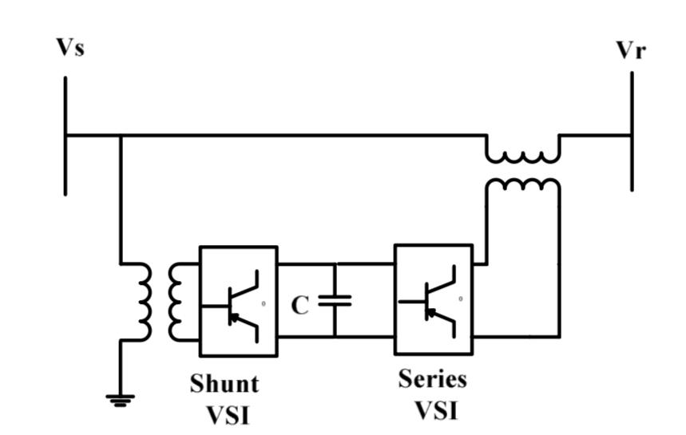

Fig.1: UPFC schematic diagram

The general form of the UPFC's power flow equations is:
Active and Reactive Power Injection by the Series Converter:
Ps = VsVrsin(δs−δr)/Xs
Qs = Vs2/Xs−VsVrcos(δs−δr)/Xs
Here:
  - Ps and Qs​ are the active and reactive power injected by the series converter,
  - Vs​ and Vr​ are the sending and receiving end voltages,
  - δs and δr are the phase angles of the sending and receiving end voltages,
  - Xs is the reactance of the line.

D-STATCOM
A Distributed Static Synchronous Compensator (D-STATCOM) is a power electronics device used to improve voltage stability and power quality in electrical systems. It functions by providing reactive power compensation, which helps maintain voltage levels within desired limits, especially during transient disturbances or fluctuations in load. D-STATCOM operates by injecting or absorbing reactive power into the grid, thereby stabilizing voltage and enhancing the performance of the system.
As shown in Fig. 2, the D-STATCOM can operate with its rated current even at reduced voltages. Its compact design and fast response time make it particularly suitable for applications in distributed generation systems, including wind and solar power, where voltage regulation can be challenging due to variable output. By ensuring a stable voltage profile, D-STATCOMs help improve overall system reliability and efficiency, making them an essential component in modern power systems.
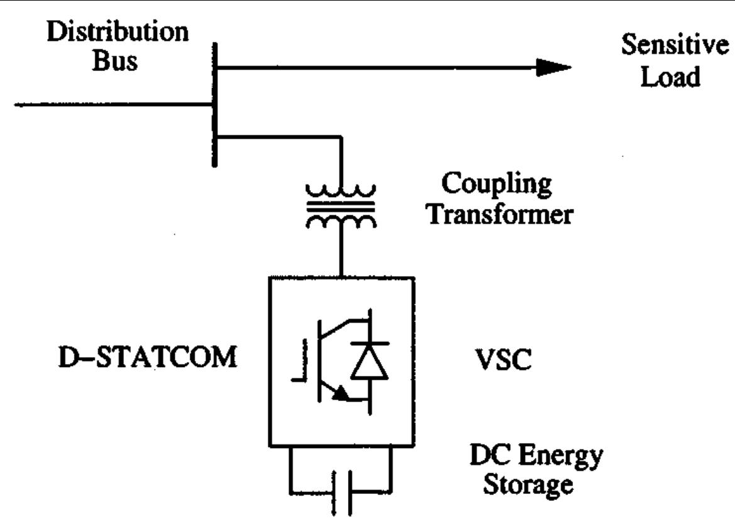
Fig.2. Schematic diagram of basic D-STATCOM

The general form of the D-Statcom power flow equation is:
The reactive power (Q) injected or absorbed by the D-STATCOM can be expressed as:
Q = Vs ⋅ (Vs − VD)/X
where:
- Q is the reactive power (positive for generation, negative for absorption),
- Vs​ is the voltage at the point of connection in the power system,
- VD is the output voltage of the D-STATCOM,
- X is the reactance of the coupling transformer.

DFIG-BASED GRID-CONNECTED

WIND SYSTEM
Doubly Fed Induction Generator (DFIG) based grid-connected wind systems are a popular technology for harnessing wind energy. In a DFIG setup, the wind turbine is coupled to a doubly fed induction generator, which allows for variable speed operation. This means the turbine can adjust its speed to capture the maximum wind energy efficiently, regardless of fluctuations in wind speed.
The key advantage of DFIGs is their ability to decouple active and reactive power control, enabling them to provide grid support services such as voltage regulation and frequency stability. The rotor of the generator is connected to the grid through a back-to-back converter, which allows for control over the amount of power fed into the grid. This configuration enhances energy capture and contributes to improved power quality by mitigating issues like voltage fluctuations and harmonics.
Additionally, DFIG systems are more efficient than fixed-speed systems and can operate effectively in a wider range of wind conditions. Their ability to provide reactive power support makes them particularly valuable in maintaining grid stability, especially in areas with high penetration of renewable energy sources. Overall, DFIG-based wind systems are a vital component of the transition towards more sustainable and resilient energy systems.
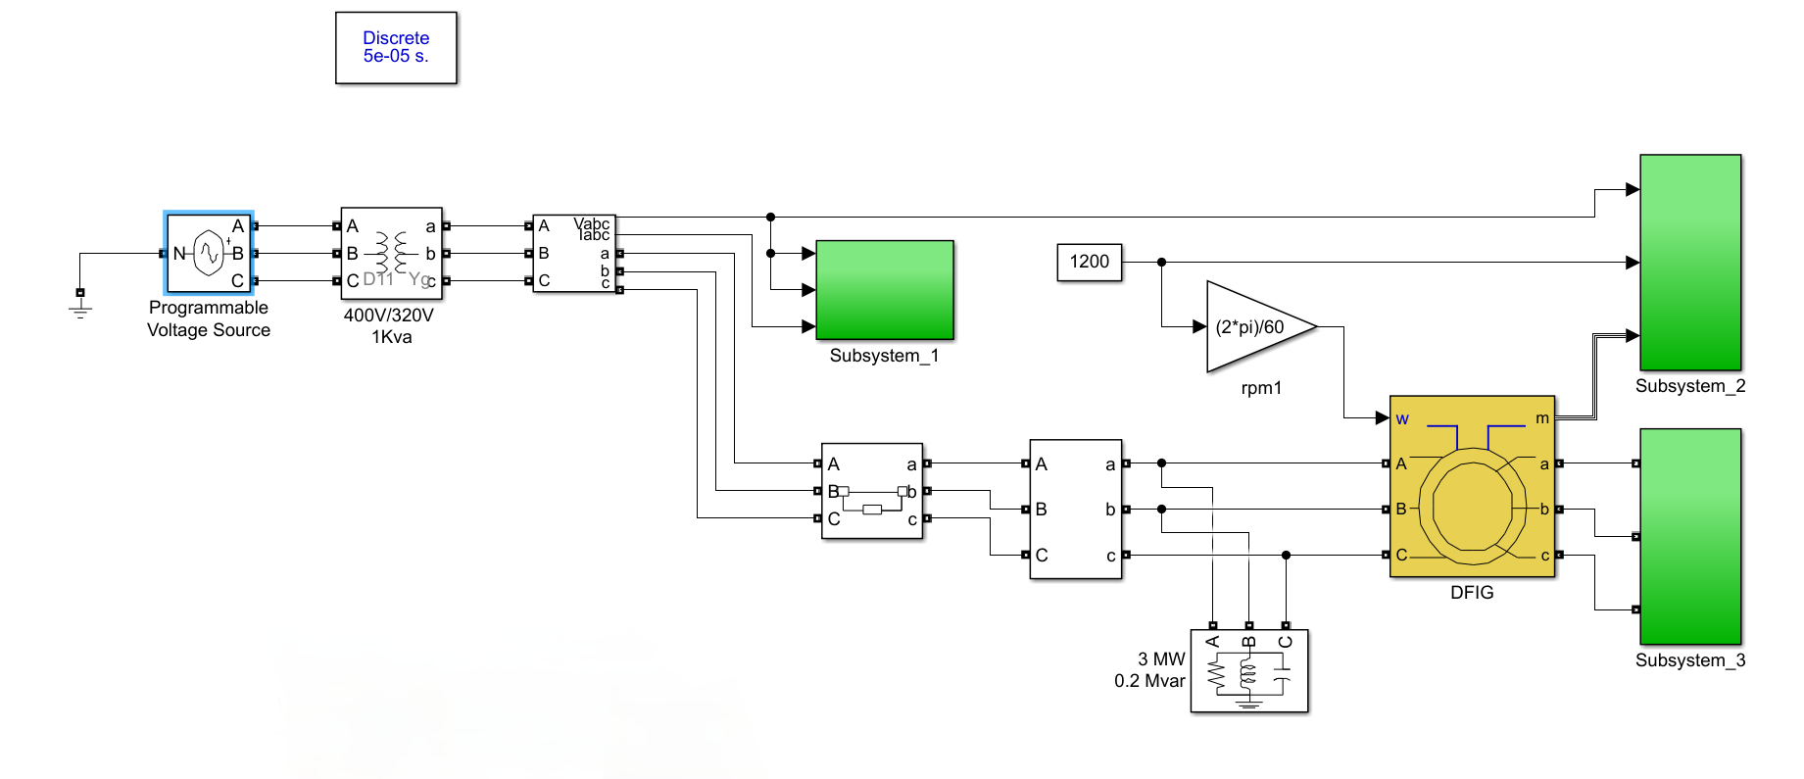
Fig.3 Simulation Model of DFIG-based grid connected wind system
In Fig.3 illustrates a Simulink model of a Doubly-Fed Induction Generator (DFIG) connected to a grid system, focusing on components relevant to a grid-connected wind energy system.
This block represents the grid connection, which supplies a three-phase programmable voltage to the system. It’s configured to deliver 400V/320V and 1 kVA. The voltage source connects to a transformer (labeled with a "Yg" configuration), which adjusts the voltage level to match the input requirements of the DFIG and other components. The model includes measurement blocks labelled “Vabc” and “Iabc” that likely measure the voltage and current of the system. These values are crucial for feedback control and monitoring power quality.Subsystem_1, Subsystem_2, and Subsystem_3 represent control or filtering subsystems related to different aspects of the DFIG system. Each of these blocks is likely responsible for specific functionalities, such as rotor speed control, stator voltage regulation, and grid synchronization. The DFIG block represents the actual wind turbine generator, rated at 3 MW and 0.2 Mvar, indicating its capacity to generate active and reactive power.There are three-phase connections (A, B, C) and additional ports labeled "w" and "m" which could correspond to the mechanical speed input and magnetic coupling parameters, respectively.A speed reference block is set at 1200 rpm. It goes through a conversion block (2*pi/60) to convert the rpm to rad/s, which is compatible with the DFIG’s control requirements. This input helps regulate the rotor speed for maximum power extraction from the wind.
This model is designed to simulate the DFIG-based wind energy system's connection to the grid, with elements focused on voltage transformation, power measurement, and speed control to ensure stable and efficient power delivery.

UPFC versus D-Statcom for Improving Power Quality

Both the Unified Power Flow Controller (UPFC) and the Distributed Static Synchronous Compensator (D-STATCOM) offer valuable solutions, but they serve different purposes and excel in various aspects. The UPFC provides comprehensive control over active and reactive power as well as voltage, making it particularly effective for managing complex power flow scenarios in large-scale wind farms. This versatility allows UPFCs to enhance system stability, optimize transmission line utilization, and reduce losses, all while justifing to dynamic changes in grid conditions and wind variability.

The option between UPFC and D-STATCOM depends on the specific needs of the wind system and the grid. While UPFCs offer broad control for large-scale integration and complex interactions, D-STATCOMs provide effective local support for voltage stabilization. At the same time , they can complement each other, improving the overall reliability and performance of grid-connected wind energy systems.

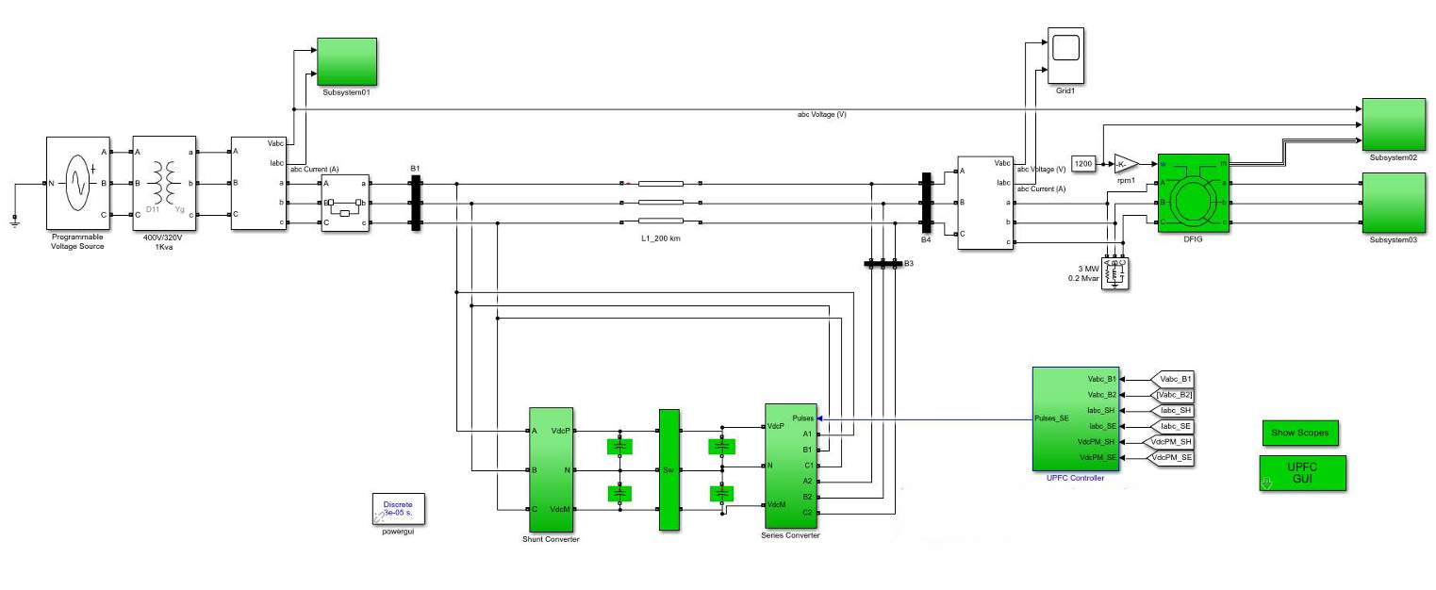
Fig.4. simulation model of DFIG with UPFC

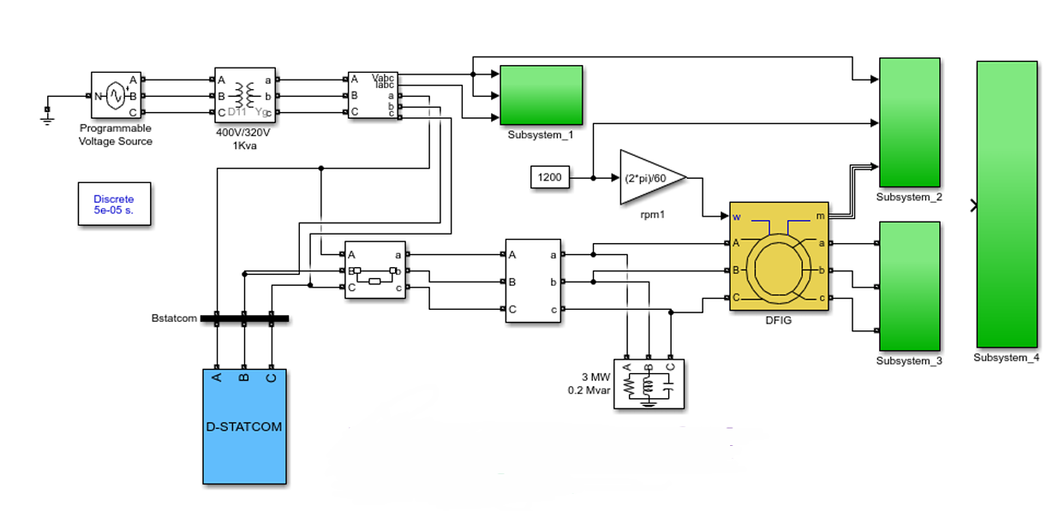
Fig.5. simulation model of DFIG with D-STATCOM

SIMULATION RUSULT

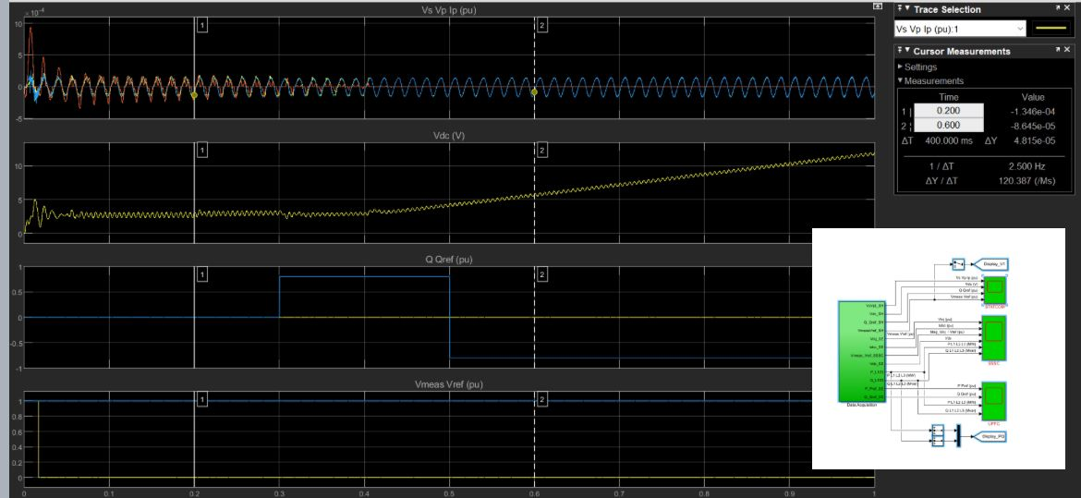
Fig.6

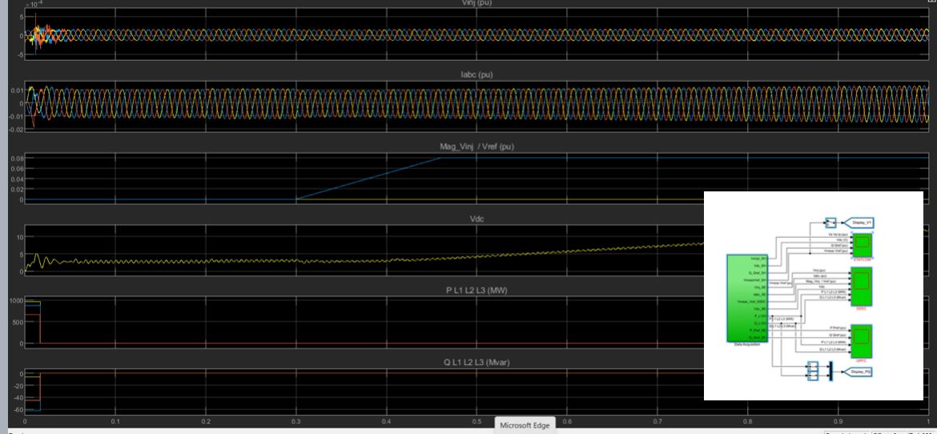
Fig.7

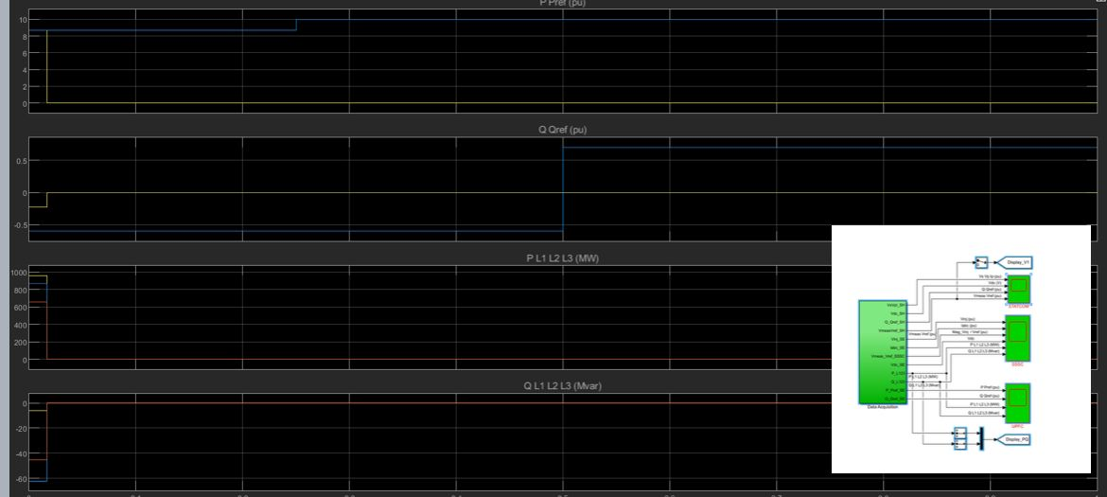
Fig.8

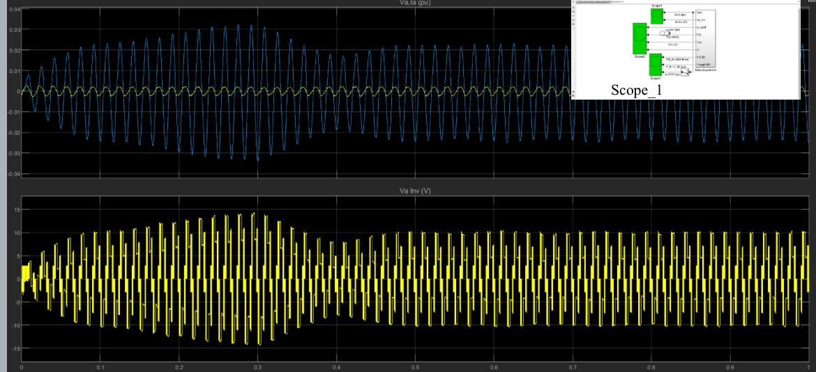
Fig.9

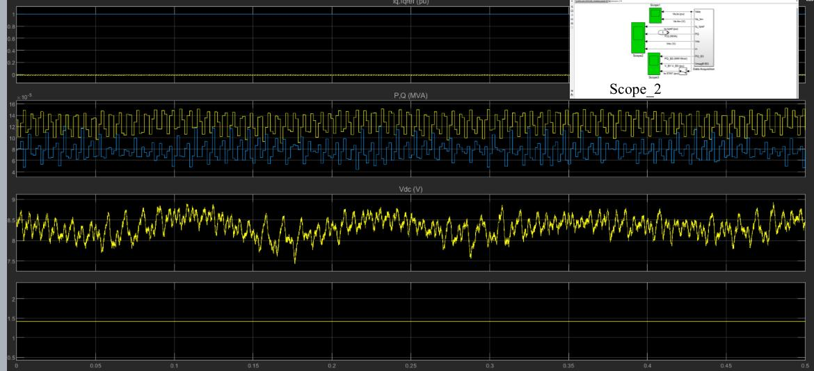
Fig.10

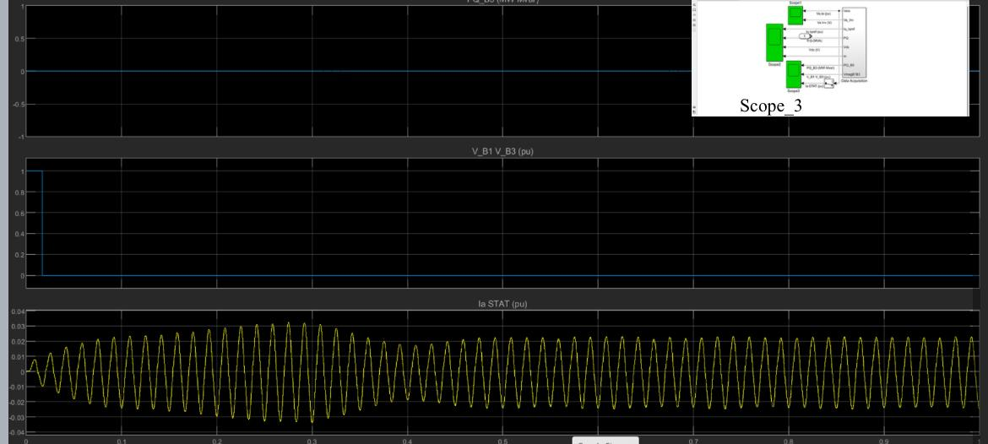

Fig.11

The simulation results emphasize the synergistic functions of UPFC and D-STATCOM in enhancing the power quality of grid-connected wind systems. UPFC proves effective in handling intricate power flow dynamics and boosting overall system stability, whereas D-STATCOM is particularly efficient in providing localized voltage regulation and reactive power support. When combined, they greatly improve the efficiency and dependability of wind energy integration into the grid.

Conclusion

The Unified Power Flow Controller (UPFC) and the Distributed Static Synchronous Compensator (D-STATCOM) play important roles in improving the power quality of wind energy systems connected to the grid. The UPFC offers comprehensive control over both active and reactive power, which helps optimize how power flows and enhances the overall stability of the system. This makes it particularly suitable for large-scale wind energy projects.

On the other hand, the D-STATCOM is effective at managing local voltage issues by quickly providing reactive power support. This is especially useful in areas where there is a lot of wind energy being used. By using both the UPFC and D-STATCOM together, power system operators can greatly improve how wind energy is integrated into the grid, leading to a more stable and sustainable energy future.

References

1) Divya D Shende, Prof.Prashant Jagtap , Prof.Rutuja Hiware, “Review On Power Quality Improvement Using Unified Power Flow Controller System In Electrical Network,” International Journal for Innovative Engineering and Management Research, Vol 10 Issue02, Feb2021 ,p.no36-41,10.48047/IJIEMR/V10/I02/09.
2) Divya Shende, Prashant Jagtap, Rutuja Hiware, “Enhanced power quality using unified power flow controller systems,” Journal of Physics: Conference Series,Nov 2021, Vol no. 2089 (2021),Issue 1,pages: 012035, doi:10.1088/1742-6596/2089/1/012035.
3) K. Waghmare and P. M. Daigavane, "Supercapacitor based Controller for electric vehicle to Grid Power," 2021 Second International Conference on Electronics and Sustainable Communication Systems (ICESC), Coimbatore, India, 2021, pp. 1-8, doi: 10.1109/ICESC51422.2021.9532879.
4) A. Moraskar and P. M. Daigavane, "Analysis & Design of Technical Feasibility of Electric Cooking for Scalable India," 2022 10th International Conference on Emerging Trends in Engineering and Technology - Signal and Information Processing (ICETET-SIP-22), Nagpur, India, 2022, pp. 1-6, doi:10.1109/ICETET-SIP-2254415.2022.9791496.
3) Sharad W. Mohod, Mohan V.Aware “Power Quality Issues and Its Improvement in Wind Energy Generation Interface to Grid System” in MIT International Journal ofElectrical and Instrumentation Engineering Vol.1, No.2, Aug 2011, pp 116 – 122.
4)Anju Jacob, Babitha T Abraham, Nisha Prakash, Riya Philip, “A Review of ActivePower Filters In Power System Applications,” in International Journal of Advanced Research in Electrical, Electronics and Instrumentation EngineeringVol. 3, Issue 6, June 2014,pp 10253 – 10261.
5) Divya Shende, Prashant Jagtap, Rutuja Hiware, “Review of enhanced power quality using unified power flow control system in electrical network,” Journal of Physics: Conference Series, Vol no.2089 (2021) ,Issue 1,pages: 012034, doi:10.1088/1742-6596/2089/1/012034.
6) A. K. Wath, P. M. Daigavane and H. K. Naidu, "A Technique of Image and Fuzzy Logic To Solve Traffic Congestion at Signal," 2022 International Conference on Smart Generation Computing, Communication and Networking (SMART GENCON), Bangalore,India,2022,pp.1-6
7) P. B. Thote, M. B. Daigavane, P. M. Daigavane, S. kamble and C. Rathore, "Hardware-in-Loop Implementation of ANN Based Differential Protection of Transformer," 2017 IEEE International WIE Conference on Electrical and Computer Engineering (WIECON-ECE), Dehradun, India, 2017, pp. 80-83, doi:10.1109/WIECON-ECE.2017.8468899.
6) Mallaiah Balaganur, Parimala V, Arunsrinivas T, Muthuraj B, Rutuja Hiware, Shradha Umathe, “DFIG Powered Yaw Function for Wind Energy Network”, 2022 International Conference on Automation, Computing and Renewable Systems (ICACRS), 13-15 December 2022, 10.1109/ICACRS55517.2022.10029128.
7) A. Bouzekri T. Allaoui, “Power Quality Enhancement of DFIG Based Wind Energy System Using Priority Control Strategies” in Journal of Electrical Engineering
8) Rakshita R. Upadhyay, Ch. V. Sivakumar, “Power Quality Issues in Variable Speed Wind Turbine and Application of STATCOM ”, in International Journal of Science and Research (IJSR), Vol. 5, No. 5, pp. 1680-1684, May 2016.
9) Vaishnavi Pachkawade and Rutuja Hiware, “Comparative Study of Different Grid Connected Wind Generator,” , Innovations in Electrical and Electronic Engineering, Lecture Notes in Electrical Engineering 1109, vol no.1,pp no. 137-150,2024, https://doi.org/10.1007/978-981-99-8289-9_11, ISSN 1876-1100 ISSN 1876-1119 (electronic),ISBN 978-981-99-8288-2 ISBN 978-981-99-8289-9 (eBook).
!0) Rutuja Hiware,Prajakta Balpande, “IoT & artificial intelligence based automated manufacturing & processing industry for better performance,” SECOND ONLINE INTERNATIONAL CONFERENCE ON RESEARCH FRONTIERS IN SCIENCES, AIP Conf. Proc. 3139, 030008 (2024), Volume 3139, Issue 1, 6 August 2024.
11) P. Ramji Thileeban, P. Suganya, “Power Quality Improvement and Harmonic Mitigation for DFIG in Wind Energy Conversion System”, International Journal of Innovative Research in Science, Engineering and Technology, Volume 3, Special Issue 1, February 2014,pp.991 - 994.
12) Mr. MilkiasBerhanuTuka,Prof.Dr.Ing.RobertoLeidhold,Dr. Mengesha Mamo “Review on Power Quality Problems on-Grid Connected Wind Power System”, International Journal of Advanced Information Science and Technology (IJAIST), Vol.5, No.4, April 2016, pp. 96 – 108.
13) Naimul Hasan, Ibraheem, Shuaib Farooq, “ Dynamic Performance Analysis of DFIG based Wind Farm with STATCOM and SVC”, International Journal of Emerging Technology and Advanced Engineering, Volume 2, Issue 7, July 2012, pp.461 – 469.
14) Suresh Maturu, U. Jayachandra Shenoy, “Impact of STATCOM and SSSC Based Compensation on Transmission Line Protection”, 16th NATIONAL POWER SYSTEMS CONFERENCE, 15th-17th DECEMBER, 2010.
15) Kandi Bhanu Prakash, "Modeling and Control of UPQC", International Journal of New Technologies in Science and Engineering (IJNTSE), Vol. 8, Issue. 11, pp. 1-5, Nov. 2022.
16) Y. I. P. Darshini, K. Deepak, U. Chaithanya, Y. Hazarathaiah, D. Vannurappa and D. S. G. Malla, "Power Quality Improvement of Standalone Microgrid during Faults on Distribution Line with DSTATCOM," 2023 5th International Conference on Smart Systems and Inventive Technology (ICSSIT), Tirunelveli, India, 2023, pp. 530-536, doi: 10.1109/ICSSIT55814.2023.10061071.
17) P.K.Dhal, C. Christober Asir Rajan, “Design and Analysis of STATCOM for Reactive Power Compensation and Transient Stability Improvement Using Intelligent Controller”, IEEE International Conference on Electronics and Communication Systems (2014)
18) Ahmed Mokhtari, Fatima Z. Gherbi, Cherif Mokhtar, Kamel D. E. Kerrouche, Ameur F. AIMER, “Study, analysis and simulation of a static compensator D-STATCOM for distribution systems of electric power”, Leonardo Journal of Sciences ISSN 1583-0233 (2014)
19) Mithilesh K. K., Srivastava S. K., Enhancement in voltage stability and reactive power compensation using D- Statcom, Int. J. Eng. Res. Tech. ISSN: 2278- 0181 (2012)
20) S.Divya, U.Shyamala, “Power Quality Improvement In Transmission Systems Using DPFC”, IEEE Sponsored 2nd International Conference On Electronics And Communication System(ICECS 2015)
21) Vaishnavi Pachkawade; Rutuja Hiware, “Modelling and analysis of grid connected doubly fed wind generator,” SECOND ONLINE INTERNATIONAL CONFERENCE ON RESEARCH FRONTIERS IN SCIENCES, AIP Conf. Proc. 3139, 040003 (2024), Volume 3139, Issue 1, 6 August 2024.

